|  |  |  |  |  |
| --- | --- | --- | --- | --- |
| **HOME** | **HRM SERVICES** | **ABOUT US** | **EMPLOYMENT** | **CONTACT US** |



**HRM OUTSOURCING SERVICES**

**(**Note: The above heading needs to be on the banner)

**Outsourcing HR can reduce your administration time and allow you to focus on growing your business.**

**HRM SERVICES WE OFFER**

1. **TENDER/BID MANAGEMENT SERVICES (HR COMPONENT)**



**(Any One of the two images to be accommodated**

In today’s competitive business world, many potential projects and services are put out to tender. That is numerous potential companies are provided with the opportunity to bid for the work.

In their bids, they will describe how their company will solve a business problem, provide the service required or supply the goods requested. They will also need to provide a competitive price for this work.

The process of designing and writing these proposals or tenders, complete with the competitive pricing, is called tender management, proposal management or bid management.

Considering how to win a tender with your price is relatively straight forward. Price your services competitively to maximise your chances. ***Bear in mind that pricing is the most common reason for being unsuccessful***

* Our team helps you for your Bid/Tender Management, with pre-project planning activities by sharing the insights of labour market analysis, which is the process of: Identifying the appropriate labour market for various sectors and types of positions. Surveying the market to determine the salaries that are being paid for like positions. Identifying market trends such as: ancillary pay, and merit and pay practices. Establishing, adjusting, and/or recommending salary changes and/or structures for staff positions.
* Sourcing suitable candidates and seeking their consent for their CVs to be the part of Tender Documents

**2. RAMIN RPO (RECRUITMENT PROCESS OUTSOURCING) SOLUTIONS**

**(Suitable Image – Choose any one from the images below)**

* Recruitment Process Outsourcing (RPO) is the process of outsourcing your recruitment function to an external partner.
* By choosing to outsource your recruitment to RBSS (Ramin Business Support Services) we will become an extension of your in-house team, working under your brand to manage all (or part of) your recruitment process, from candidate engagement and sourcing to pipelining and onboarding.
* RAMIN assists you in Sourcing, Recruiting, and Onboarding personnel to help you save money and gain a strategic advantage. Because of our significant multi-industry experience, we are able to leverage our international reach.
* Ramin RPO assists businesses in developing, implementing, and optimising recruitment strategies and processes.
* Ramin's RPO service manages the complete company's screening, sourcing, and monitoring methods. We provide your HR team complete control over Interviewing, Hiring, and Onboarding new workers.
* Our RPO services make your recruitment process easier and faster. We help you expand your hiring capacity, reduce turnaround time, and improve candidate satisfaction.
* When you choose RAMIN for your RPO needs, you'll be working with a firm that has extensive experience providing solutions for a variety of sectors.

**RAMIN’S RPO SERVICE PORTFOLIO**

|  |  |  |
| --- | --- | --- |
| **ON-DEMAND RPO** | **SELECTIVE RPO** | **END TO END RPO** |
| ***On-demand RPO*** is used to meet a temporary need to hire permanent talent quickly. That makes it different to contingent RPO, which applies techniques typically reserved for hiring permanent staff - such as employer branding, EVP, and technology implementation - to the hiring of contingent or temporary workers. | ***Selective RPO*** addresses and strengthens specific components of your company's internal recruitment process. Many employers strictly outsource sourcing and screening processes, or candidate management. With selective RPO, you receive best practices for those specific services only. | ***End-to-end RPO*** is a complete outsourced recruitment solution, typically delivered over multiple years. Managed by a third-party partner, an end-to-end RPO solution can encompass every component of your talent strategy. These components may include: candidate attraction. candidate screening. |

**3. IT/SOFTWARE SERVICES**

**Choose any one from the images below**

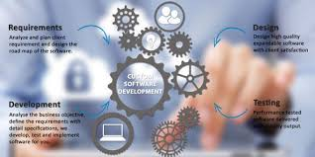

**(Suitable Image)**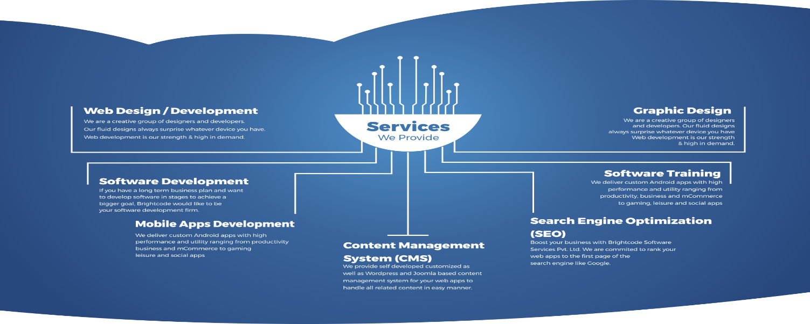

**(Suggestive image where we can show only three services as mentioned)**

1. **Mobile Application Development**

* We help customers across sectors and industries with extending their businesses to the mobile channel and distinguish their brands with human-centric digital experiences.
* Our mobile app development services include consultation, programming, user interface/user experience (UI/UX), and quality and security testing for iOS and Android platforms and operating systems.

1. **Web Application Development**

* We provide cost-effective web development services with a money-back guarantee and correct optimization in accordance with search engine recommendations.
* We've perfected the skill of developing a website that matches and fits your company demands.

1. **Performance Testing**

* We offer end-to-end performance testing services to assist our clients in launching future-proof applications that are highly responsive, available, and scalable.
* Client-server, online, distributed, mobile, cloud databases, high-volume transaction systems, and very sophisticated applications are all part of our Performance Testing and Load Testing services.

**Sample Enquiry Form**

